PRAKOM PERTAMA_Wardiman Perdian

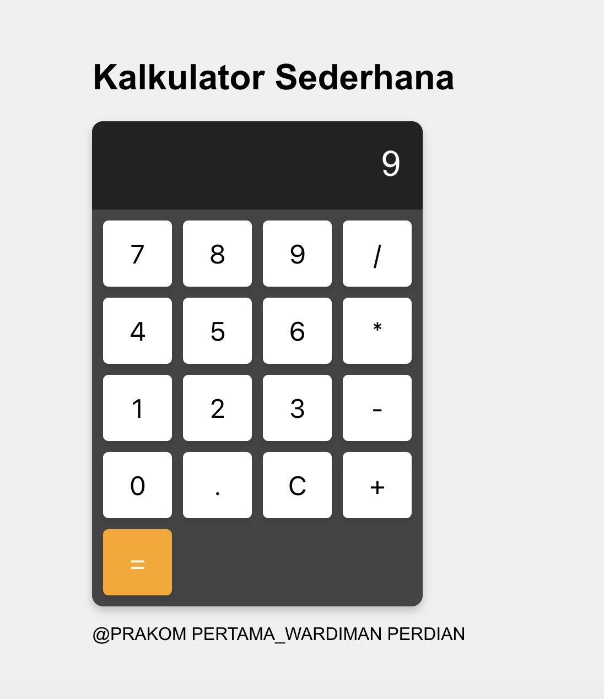Link Github : <https://github.com/Diman12345/calc/tree/main>